

HOW TO – GDMA Linux Target Configuration
(GroundWork Distributed Monitoring Agents V2.1)

Jan 21, 2010
Version 1.0

Prepared by:

Kevin Stone
Table of Contents
Summary 3
Prerequisites 3
GroundWork Monitor Setup 3
Create Monarch Monarch Group for unix GDMA targets 3
Configure Monarch Group for unix GDMA targets 4
Upload and Import GDMA Linux Base OS Host and Service Profile 5
Review and Modify gdma-linux host externals properties 7
Configure A GDMA Linux Host 8
Add new host to Monarch Group 9
Commit changes and Build Externals 10
Install GDMA Agent on Target 10
Additional Information 11

Summary

This document describes the steps necessary to configure GDMA agents for Linux systems. This document describes a basic installation. For information on advanced configurations contact Groundwork support.

Prerequisites

The following prerequisites exist for configuring Linux GDMA Agents:

- GroundWork Monitor Enterprise 6.0.1 correctly installed.
- GroundWork Monitor GDMA Master Server Configuration complete.
- Administrative access to Groundwork and Target systems and familiarity with Groundwork, Nagios and Monarch
- Taking a backup of the monarch database is highly recommended before beginning this operation See Bookshelf →System Maintenance→Backup and Restore for details

GroundWork Monitor Setup

Create Monarch Monarch Group for unix GDMA targets
In Configuration→Groups→
  - Select New
  - Fill in Group Name feild E.G. “gdma-unix”
  - Select Add to create the monarch group.

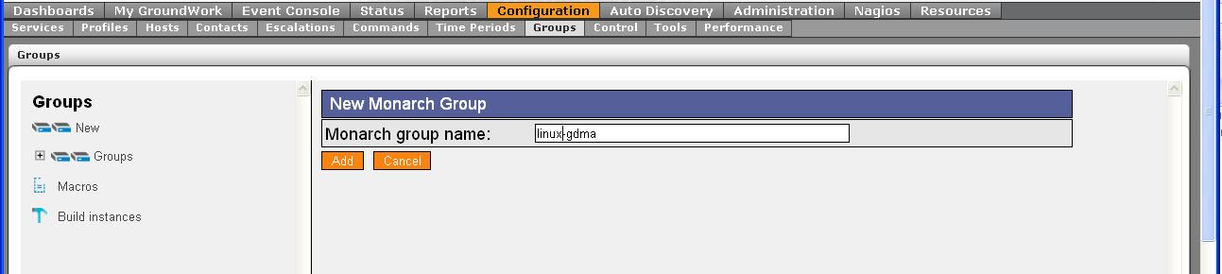

Configure Monarch Group for unix GDMA targets
Monarch groups are used to control creation of monarch external definitions used by GDMA agents.

In Configuration→Groups→
- Expand Groups
- Select group gdma-unix
- Select detail page of gdma-unix
- Fill in Description[Optional]
“Monarch group for configuration of gdma targets”
- Fill in Build directory
“/usr/local/groundwork/apache2/htdocs/gdma”
- Leave all other fields blank
- Select Save

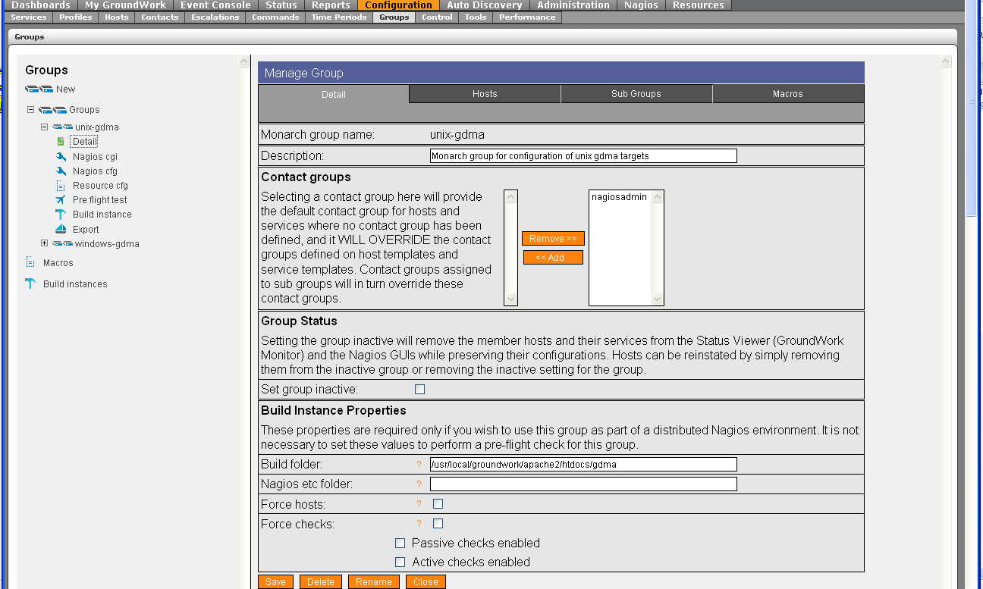

Upload and Import GDMA Linux Base OS Host and Service Profile
The Linux Base OS profile provides configuration parameters for the creation of linux targets.

In Configuration→Profiles
- Select Profile importer
- Scroll to bottom of screen
- Select Browse and enter location of “gdma-linux-base-os.xml”
- Select upload
- Select Browse and enter location of “service-profile-gdma-linux-base-os.xml”
- Select upload
- Select Browse and enter location of “perfconfig-gdma-linux-base-os.xml”
- Select upload

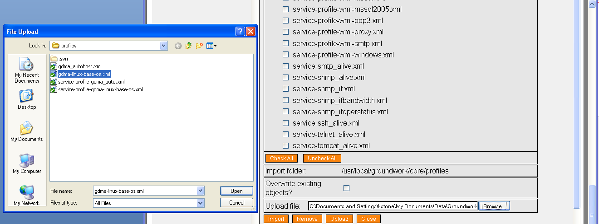

- Toggle Checkbox for gdma-linux-base-os.xml

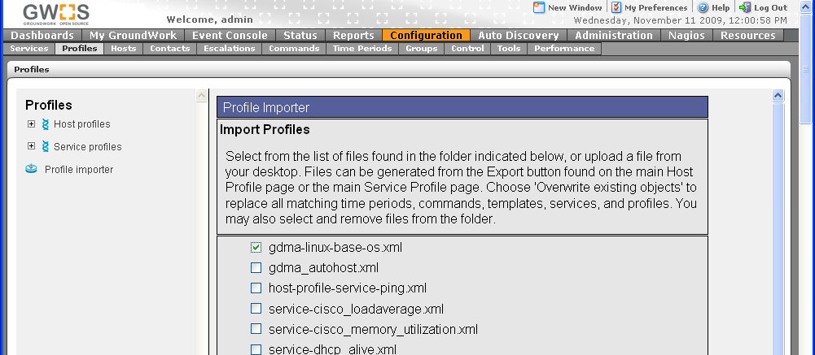
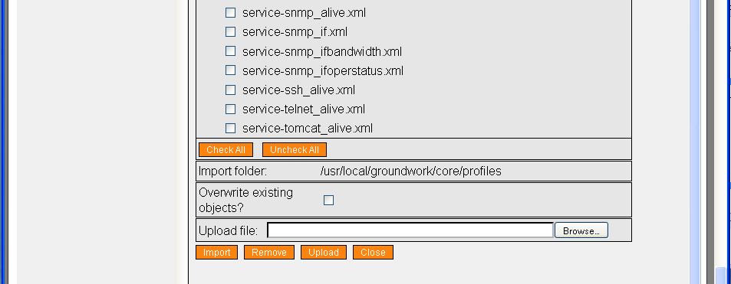

- Select Import

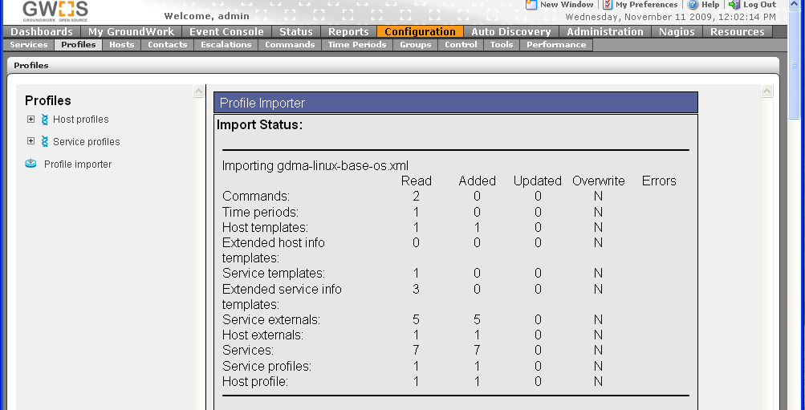

Review and Modify gdma-linux host externals properties
In Configuration→Hosts→Host Externals
- Select Modify
- Select gdma-linux

Modify Target_Server parameter
This parameter controls where GDMA agents will download their configurations from and where they will send check results. The parameter must be in the form of a url. This parameter is normally set to the hostname or ip address of the Master system. For details on this and other configuration parameters see GDMA Agent Configuration Reference.

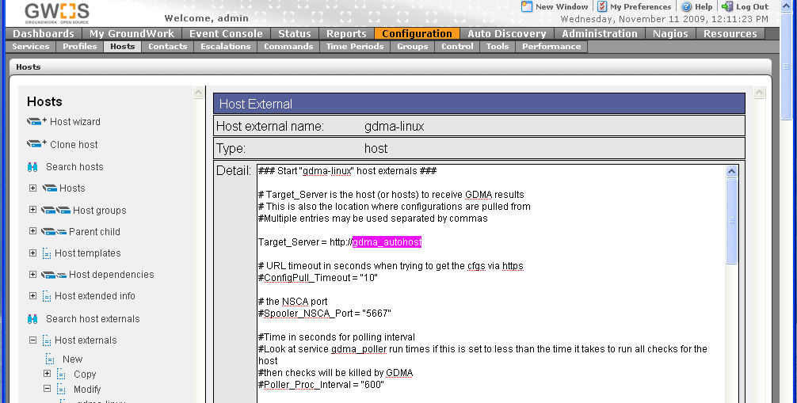

Configure A GDMA Linux Host

In Configuration→Hosts
- Select Host Wizard
- Fill in Host Name E.G “gdma_test”
- Fill in alias E.G.“gdma_test”
- Fill in address E.G.“196.168.11.220”
- Select gdma-linux-base-os Host profile

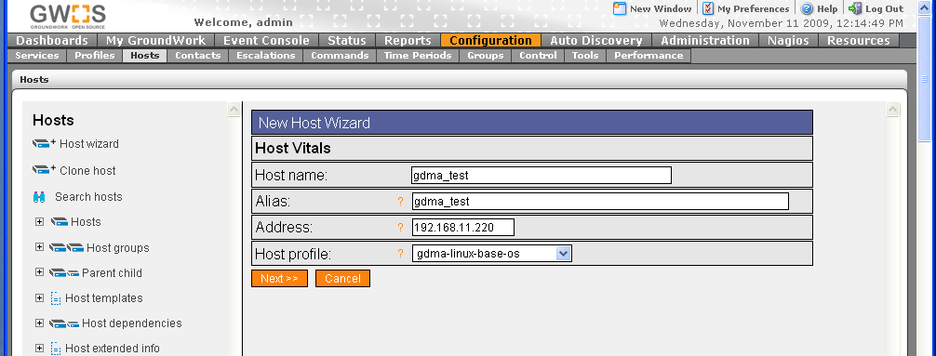

- Select Next,Next,Next,Next,Continue

Add new host to Monarch Group
In Configuration→Groups
- Expand Groups
- Expand unix-gdma
- Select Detail
- Select Hosts Tab
- Toggle Checkbox for host E.G. gdma_test
- Select Add Hosts
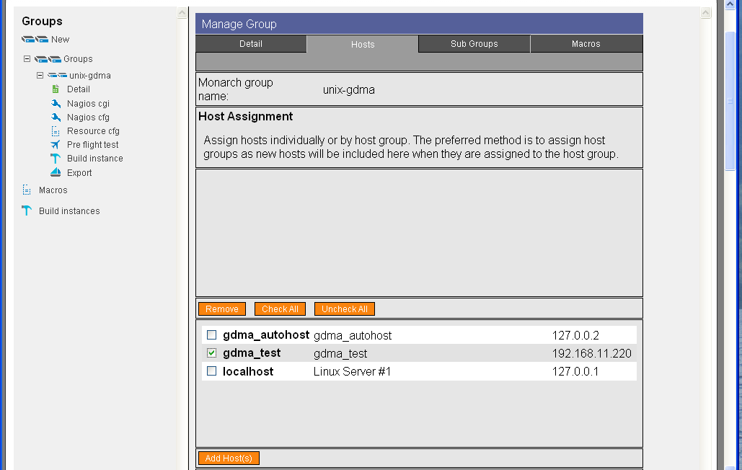

Host will appear in the upper field as an assigned host.

Commit changes and Build Externals
To commit changes to groundwork and create gdma configuration file

In Configuration→Control
- Select Commit, Commit
- Select Run externals

The configuration file will be created in “/usr/local/groundwork/apache2/htdocs/gdma” as defined in the unix-gdma monarch group. The filename will be gwmon_$hostname.cfg in this example gwmon_gdma_test.cfg

#ls -al /usr/local/groundwork/apache2/htdocs/gdma/gwmon_gdma_test.cfg
-rw-r--r-- 1 nagios nagios /usr/local/groundwork/apache2/htdocs/gdma/gwmon_gdma_test.cfg
#

Additional Information
GDMA Autoconfiguration
GDMA Master Server Howto
GDMA Windows Target Howto
GDMA Configuration and Installation Reference

See Bookshelf Using Applications→Configuration→Configuration Scenarios→Configuring Externals
This directory is controlled by the GDMAConfigDir Configuration parameter. Do not modify this path without consulting GDMA agent documentation.
You may optionally place the host in a hostgroup and configure additional host, service and notification options.

